RESOLUTION NO.__________

RE: CERTIFICATE OF APPROPRIATENESS UNDER THE
PROVISIONS OF THE ACT OF THE PENNSYLVANIA
LEGISLATURE 1961, JUNE 13, P.L. 282 (53
SECTION 8004) AND BETHLEHEM ORDINANCE NO.
3952 AS AMENDED.

The applicant proposes to proceed with the next phase of re-roofing
their house at 223 E. Church St.

NOW, THEREFORE, BE IT RESOLVED by the Council of the City of Bethlehem that a Certificate of Appropriateness is hereby granted for the proposal.

Sponsored by: (s)

(s)

ADOPTED BY COUNCIL THIS DAY OF

(s)
President of Council

ATTEST:

(s)
City Clerk

HISTORICAL & ARCHITECTURAL REVIEW BOARD

The applicant proposes to proceed with the next phase of re-roofing
their house at 223 E. Church St.

APPLICATION #3:

Susan Parks
223 E. Church St.
Bethlehem, PA 18018

OWNER:

__________________________________________________________________________

The Board upon motion by Beth Starbuck and seconded by Marsha Fritz adopted the proposal that City Council issue a Certificate of Appropriateness for the following:

- Approval for next phase of re-roofing.

2. All materials have been previously approved.

3. The motion was unanimously approved.

__________________________________________________________________________

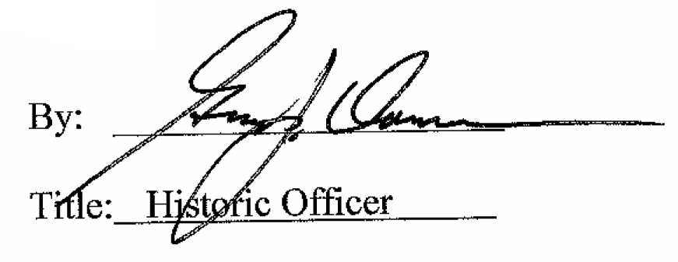

Date of Meeting: May 2, 2018

